CARD 7

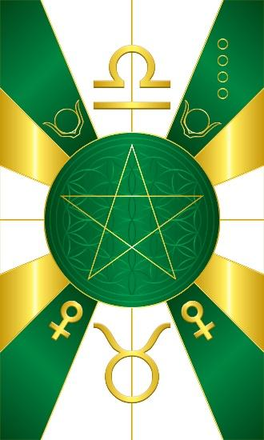
Card 7 represents the energy of Het-Heru/Oshun. The colors along the outside of the circle are Green, White, & Gold/Yellow. In the middle is the 5 pointed star. Above is the glyph for the constellation of Taurus, and below the glyph for the constellation of Libra. In the bottom corners are the astrological glyph for the planet Venus to which Het-Heru and Oshun correspond. In the upper corners are the solar disk and bull horns that correspond to Het Heru or house of Heru, which is the container for Fire.

Comments by Baba Awodele

